**“SACCOs Loan Service’s Road to Success”**

**A Success Story of SACCO Loan Beneficiary**

**October 2022**

**Chiro**

***“SACCOs Loan Service’s Road to Success”***

**A Success Story of SACCO Loan Beneficiary**

1. **Background**

Savings and Credit Cooperatives (SACCO) provide the capital to improve the income of the farm and non farm sector. Still most of the poorest do not have access to the formal financial institutions in Ethiopia and they depend on informal sources for their credit needs.

Access to finance is one of the critical interventions to improve the livelihoods of pastoral communities in Ethiopia. Unlike other formal finance providers (banks, insurance companies and microfinance institutions), Savings and Credit Cooperatives (SACCOs) are one form of sustainable financial institutions that have a comparative advantage of providing financial services to the financially excluded population, particularly to remote rural households.

Ashraka Usman, a resident of Chitu Kora kebele, Gumbi bordode district, West Hararghe zone of Oromia Regional State, Ethiopia, was born in a place specifically known as “Chitu” of same kebele, which is adjacent to a main asphalt road to Harar/ Dire Dawa, in the year 1977 GC.

Ashreka Usman, mother of 6, was married to her husband Ato Mohamed Edo 18 years ago. She has hardly attended school and had no formal employment. The livelihood of the family was depended on a small income obtained from simple seasonal agricultural practices which depended by seasonal/rain condition that did not guarantee family’s minimum consumption let alone satisfying other needs. Besides, three Shoats and a cow was the only asset she had for living.

Situations became difficult for Ashreka’s husband to fulfill basic needs of the family. Ashreka has been stressed and worried about the situation that she and her family were living in. She was an empty handed house wife having five daughters and three sons.

Fortunately, she had long time experience in practicing grain-retailing business in local market during her early ages (before marriage). Although she had the skills and desire to trade in grain, she could not work because she did not have the money on her hand. *“if I had money, I would still want to do this job and help my family with the income I earn.” s*aid Ashreka.

She went to many neighborhood people and asked them if she could get a loan, but nobody has given her loan. *“No place I haven’t gone to and no door I haven’t knocked on to get a loan. but I couldn't find it. some people you ask for a loan don't want to lend you money even though they have it. Because they suspects you of not paying them back”* Ashreka explained the sufferings she faced.

1. **Response**

Financial cooperatives play a positive role in reducing poverty and contributing to economic growth at micro and macro levels. (OLLRP). Considering this reality the Oromia Region Lowland Livelihood Project (LLRP) during very beginning of its first phase, has included financial provision/support in its major activities planned to be implemented in selected areas of the region. OLLRP supports the establishment, financial provisions, capacity building and strengthening of the pastoral and agro pastoral Saving and Credit Cooperatives in selected project districts under the Chiro Cluster. The LLRP started provision of supports to SACCOS in the year 2020 GC. The project, in collaboration with the woreda and Zonal level Cooperative Offices of its working area, has established total of 15 new SUSACCOs in three project districts. With the financial support obtained from the project, management committee members of all SACCOs were trained on different topics. In the year 2021 GC, the project disbursed a loanable grant/seed money amounting Birr. 3 million for total of 15 SACCO members through their respective SACCOs in the three project districts. Besides, office furniture and financial documents were provided for all newly established SACCOOs with the project support.

The Lowland Livelihood Project (LLRP) was funded by the World Bank and IFAD. It implemented under the Ministry of the Irrigation and Lowlands in national level and under the Oromia Irrigation and Pastoralist Development Office in regional level.

This series of case stories highlights some of the experiences of loan fund beneficiaries across the project working area under the Chiro Cluster.

In an era of inflation, it is essential for a woman to be financially independent for the economic upliftment of the family as well as welfare of the society. Ashraka Usman, is a true embodiment of these facts.

Ashreka greatly desired to be self-dependent and educate her children. Neither illiteracy nor empty handedness could stop her from making her way to success. She understood that relying on a small and impermanent income obtained from her husband merely would not bring improvement in living condition of her family unless additional and permanent income obtained from other sources.

The determined woman, Ashreka did not give up. when she has no one to lend her money, she decided to do whatever she could with the little money (700 birr,) she had saved for the trouble. She started grain-retailing business on roadside. But could not extend it because the profit that she was able to make from the business was not worth mentioning for the fact that she was short of money so that she could not buy much grain and sell it back. *“Had not been encountered shortage of working capital, I would have get better profit from the business.”* Said Ashreka.

Once up on a time, while she was thinking about how to change the hand-to-mouth living condition of her family, she has got a chance to attend a meeting in 2020 GC., where she got an opportunity to interact with Cooperative experts and heard a blessed news that the “Lowland Livelihood Resilience Project (LLRP)” in collaboration with Cooperative Office, wanted to screen people who were interested in becoming members of the new SACCO.

A few days after she heard the information, membership registration was started. Discussing with her husband, Ashreka immediately get registered and becamme a founding member of Chitu Kora saving and credit Cooperative that had 226 total members among which 78 male and 148 were female.

The SACCO is one of the five SACCOs established with the support of LLRP in Gumbi Bordode district in the year 2020 GC. LLRP has provided financial support (seed money grant) amounting Birr 200,000 for each SACCOs including Chittu kora in 2021 GC.technical support and regular supervision was also provided jointly in collaboration with district Cooperative office. She has also taken the basic training that was provided by LLRP at district level.

1. **Result**

Ashreka explained that, the basic training that has been given on the time of establishment, has helped her understand the goal and objective of the RUSACCo and thereby made her highly motivated to become active member of the RUSACCO.

Then after, Aashreka convinced herself to put her saving (Birr 50) to the RUSACCO in monthly basis. Short time after establishment of the RUSACCO, Aashreka applied to the loan committee and borrowed 7,000,00 birr that has paved a way for her current success status.

As she had always wanted to retail grains She chose to invest all her borrowed money in grain retailing business. Hence, The moment she obtained the loan, she rushed to collect locally available grains in different variety and in larger quantity that she never could before. Finally she took them to the neighboring towns, mostly (Bordode and Asebot), where she could earn better price. Ashreka told that neither grain type nor market place limited her while running her business.

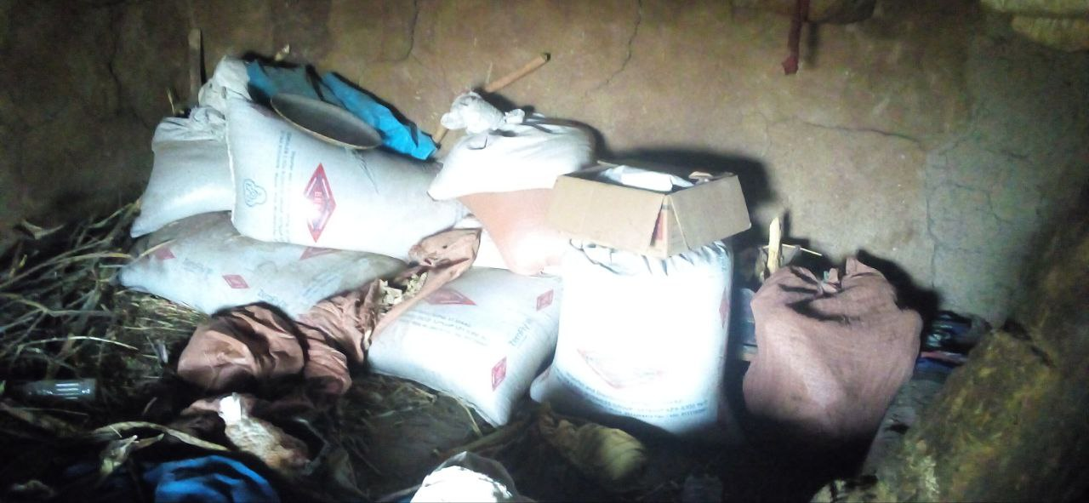

*Fig.1. Some of the grains Ashreka collected for sale*

*”If I believe that it is profitable, I buy and resell any grain I get. That matters is profit!!”* she explained. However sorghum and maize were major grains she mostly retailed. Her grain selling business became profitable. She was able to save some amount of money from her business in addition to the monthly saving she put to her RUSACCO.

The loan she borrowed from her SACCO has significantly contributed a great role in her family’s life improvement. She explained that, previously (before loan service), she used to buy and sell limited variety and small quantity of grain. Similarly, the profit she used to obtain was also limited.

Ashreka, who has set an examplery for other women, is a successful entrepreneur. Her success has persuaded many women in the area and she has become a role model for them.

Now, owing to LLRP and her saving and credit Cooperative, the loan enabled her to expand her business (from small-scale retailing to somewhat bulk quantity), sustain her existing customers and attract new ones by providing satisfactory services (in variety and quality of grains). She now able to anticipate better and possible profit and expect minimum risks of loss as well.

Aashreka explained the situations she passed through; *“Challenging days has passed, thanks to my God and LLRP/SACCO; my families living condition has been completely changed”* she said. Basic needs of her family members have been fulfilled she has sent additional 2 of her children to school which she couldn’t to do before due to un affordability to cover school costs, she is able to feed them at least 3 meal times in a day and can provide them new cloths. Besides, Aashreka was able to buy an ox for Birr 14,000 with a profit she secured from the business. With current market price the ox was estimated to be birr 20,000.

Ashreka could able to save half of a profit she earned from her grain retailing business on each market day while she used the rest portion for household consumption. At a moment she was interviewed, Ashreka had birr 5000 on hand, 3000 on grain stock and 20,000 on an ox. Hence her total asset from the business including loan has been birr 28,000.

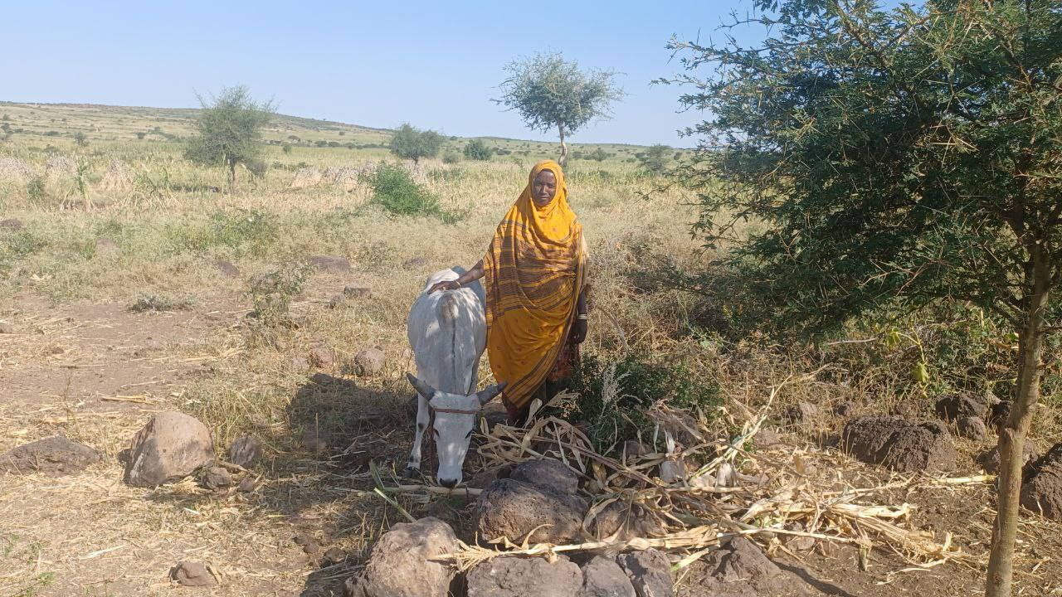

*Fig. 2 Asset built from Loan Service*

Filled with smiles,Ashreka said, *“before I got this loan, I didn't have anything even to buy medicine for his children if they got sick. It was difficult to buy notebooks for children. Thanks to God, but today we are in a better situation. I am educating all my children. I am providing for their needs as much as I can”*

Aashreka also explained that several factors helped her ensure success of her business. According to her, availability of loan service, her experience in grain retailing activity and awareness creation (training) gained on objective and goal of RUSACCO have helped her become successful in her business.

According to her, the maturity date of her first loan was approaching and she was ready to effect the repayment before due date so that she would apply for another loan term. *“I take it as my own money… Had I borrowed from an individual I would have never had the freedom and confidence in my neighborhood.”*

Ashreka with high levels of determination, saying that *“I do not want to sit and wait for miracles to happen in my life but is ready to work to make the miracles happen.”*